# 1. Short GRL Overview & Analysis

**GRL Elements (Intentional elements, IE's)**

* Softgoal
* Goal
* Task
* Resource
* Belief

**GRL Links**

* Decomposition
  + *Means-end* links
  + AND/IOR/XOR decomposition
  + Relations between an IE and a set of IE
  + Decomposes(IE,{IE1,...,IEn},Type), Type = AND/IOR/XOR
* Contribution
  + Indicate *impact* of one IE's satisfaction on another IE's satisfaction.
  + Relation between any two IE
  + Valued:
    - Qualitative: make, help, some positive, non, some negative, hurt, break
    - Quantitative: domain [-100,100]
  + Contributes(IE1,IE2,Value)
* Dependency
  + Used between IE's of different actors.
  + Relation between any two IE
  + Depends(IE1,IE2)

**GRL Components**

* Actor
  + A grouping of intentional elements and links.

**GRL Evaluation Algorithms**

* Three types of evaluation algorithms:
  + *Qualitative:* Useful in early phase when quantative values are unknown
  + *Quantative*
  + *Hybrid*
* All algorithms have the following steps:

1. Assign satisfaction values to subset of IE's (*GRL Strategy),* qualitative/quantitative
2. Propagate values through links in the following order:
   1. Decompositions
   2. Contributions
   3. Dependencies
3. Compute an actor's satisfaction level using an *importance* attribute

* Defines relative importance of IE over other IE's bound to an actor
* Qualitative: (H)igh, (M)edium, (L)ow, or None
* Quantative: [0,100]

# 2. GRL from an Argumentation Perspective

GRL models are very closely related to practical reasoning (as we discussed in RENext2015, ER2016). In fact, we can view A GRL diagram as a collection of practical reaoning arguments.

Lower costs

+75

Use open source software

The practical reasoning argument in this case is something like:

*Action "use open source software" should be performed, because performing this would promote goal "lower costs"*

**ER2016 Approach**

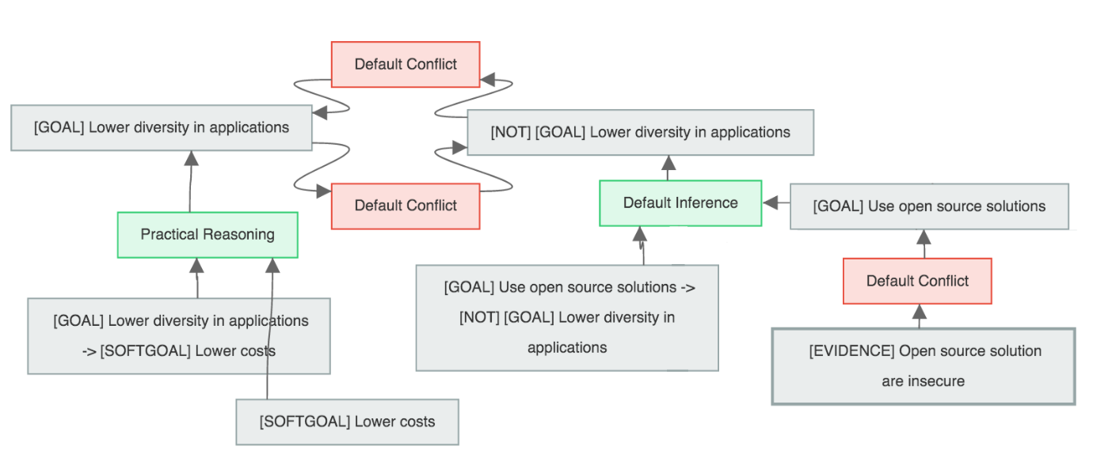We started from an argument diagram such as the following:

Which we then translated into the following GRL model:

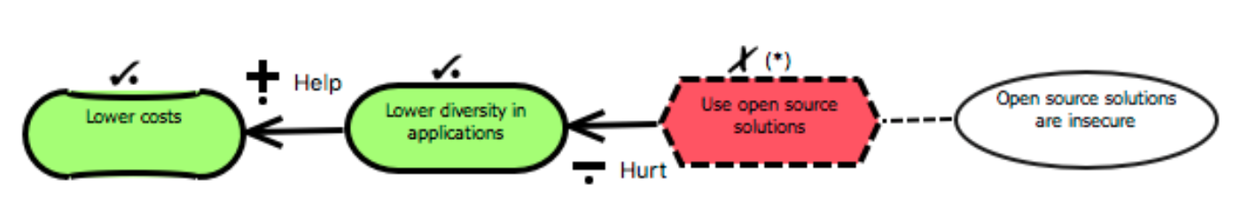

* **However, does the argument web contribute anything to the GRL model?**
* **What useful information does the argument diagram contain that is not in the GRL model?**
* **Is this the right way of using argument extension?**

**Proposed New Approach**

What do stakeholder argue about? Actually they are involved in some *decision making process*, with as a result a goal model. Jureta *et al.* visualize it as follows:

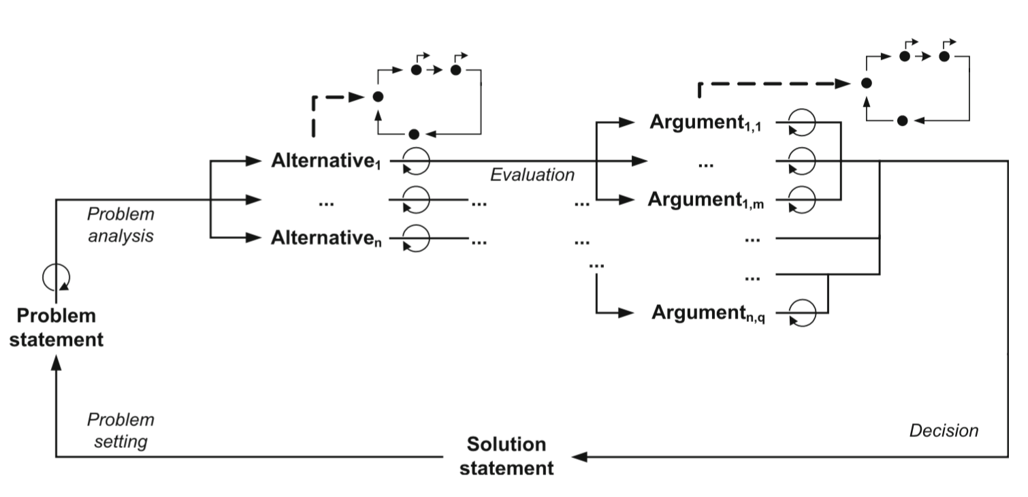

* The *problem statement* represents a problem to be solve, an issue to be discussed, etc.
* The *alternative* are possible solutions, motivated or attacked by arguments.
* The *solution statement* contains the alternative chosen / action taken.

They then give an example of stakeholders arguing about some meeting scheduling problem using this methodology.

Here are some alternatives and actions.

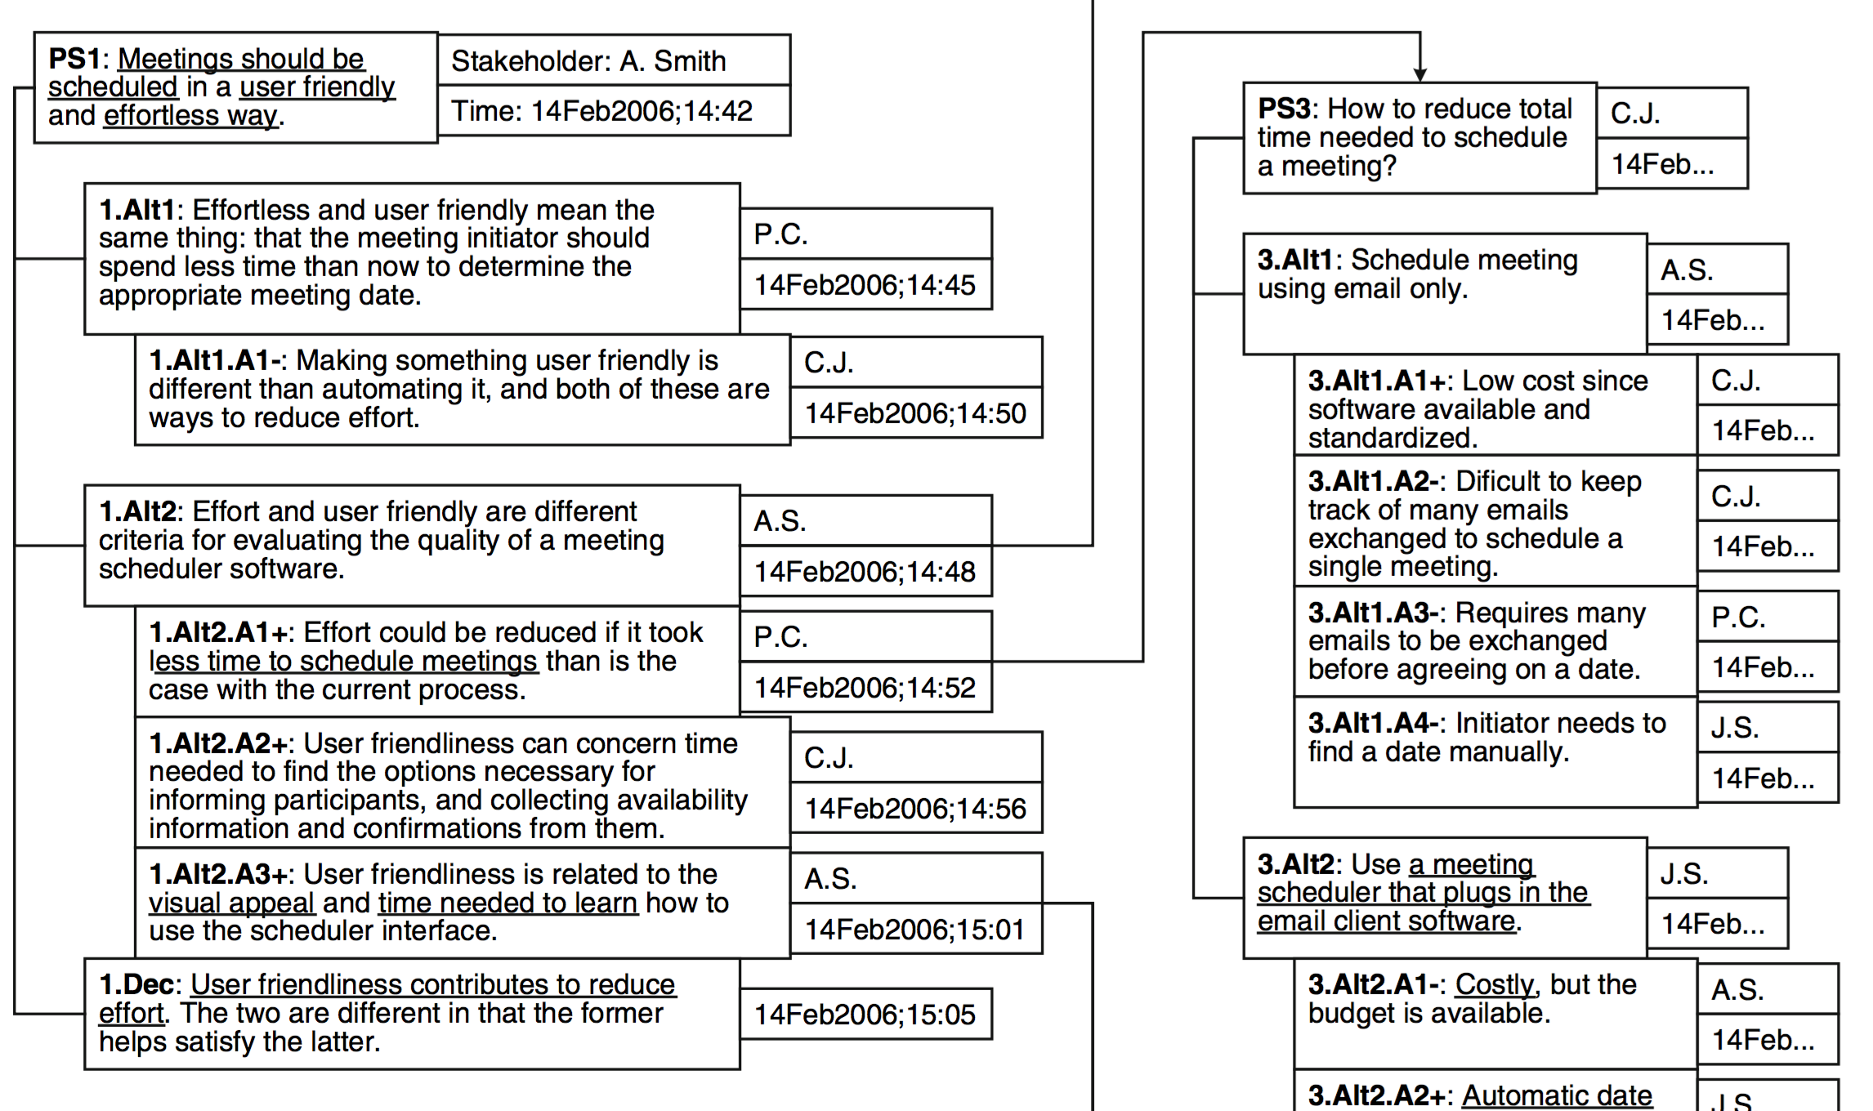

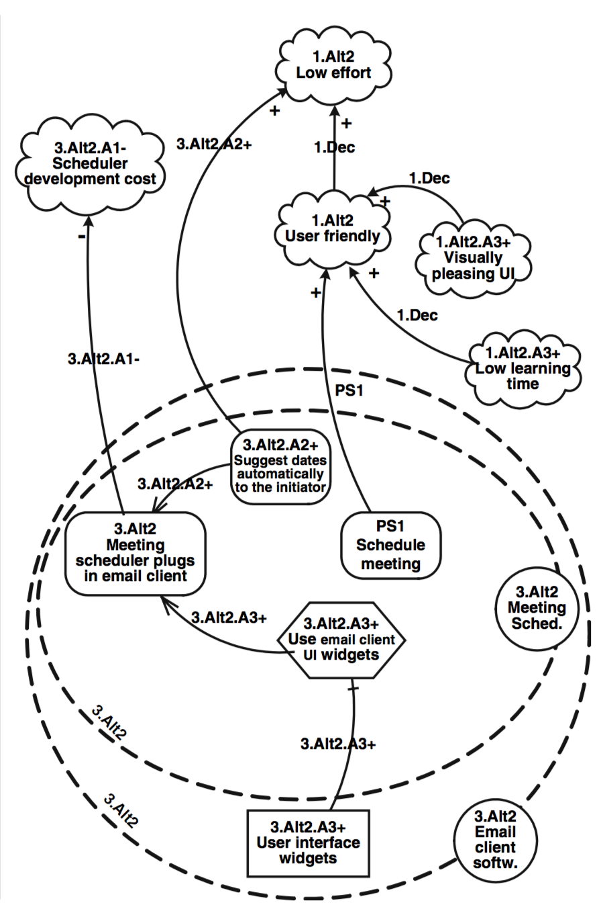

And the resulting goal model is depicted on the right.

We see there are some relations between the two models (decisions are depicted in the goal model), but Jureta *et al.* do not explain further how this translation should proceed.

Later in the paper, they formalize the arguments above using structured argumentation, just like we did. They then use argumentation theory to decide which parts of the goal model are shown and which are not.**Analysis of Jureate *et al.***

* I think that their methodology is useful and makes sense.
* Using arguments to decide on alternatives seems to fit.
* They do not give details for a translation from the arguments to the goal diagram.
* They also do not implement anything.

**What I think we should do:**

* Use the methodology of Jureta *et al.* (i.e., the decision process above).
* Use arguments in the same way as they did, namely to decide on alternatives.
* Provide more details on how the translation is done. There are elements that are not translated (for instance, it is not clear whether an argument is a task or a goal etc), but this is done on purpose. I think this is good, because it is part of the goal modeling process. However, we could write software that assist the user in this.
* Implement it as follows: Add an additional layer onto URN. So we have ARG, GRL, and UCM. ARG is a different modeling language in which users provide problem statements and alternatives.
* Based on this, the user can create a GRL model, but details have to be filled in.
* In this way we have traceability form ARG elements (arguments) to GRL elements.

**Questions:**

* Is this enough contribution for a journal paper?
* If not, what should we add?
* Can critical questions play a role here?